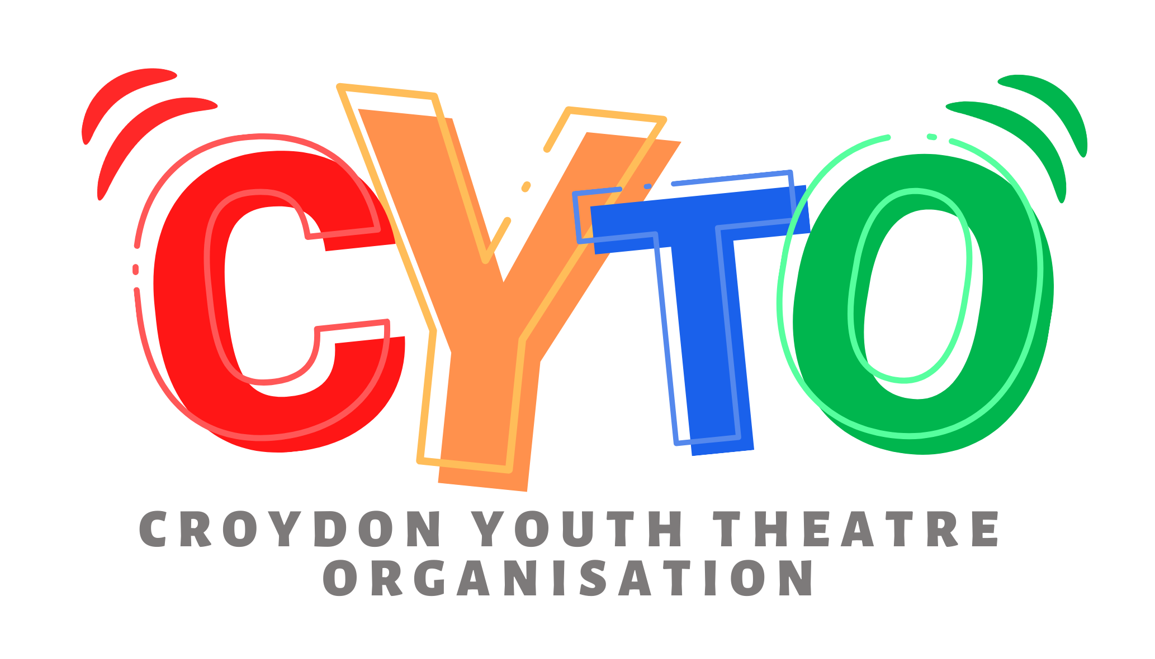
Safeguarding Concern / Incident Report Template

NOTES: The following form is provided as a template only and must be customised as required by the person completing the form.

Safeguarding incident or concern:
This form is designed to report any safeguarding incidents or concerns. It should be completed by the worker who has been disclosed to, who witnessed the incident, was most directly involved or who provided first aid if relevant. Once completed it must be submitted as per the organisation’s reporting protocols. |  | REFERENCE NUMBER

Name & role of person completing this form:

Programme name: | Date form is completed:

Details of child, young person or adult at risk:
Name: | Date of Birth:

Parents/carers details:
Name: | Address:
Contact number: | Email address:
Have parents/carers been notified of the incident?: Yes / No | If yes, please provide details:

Details of reportee:
Are you reporting your own concerns or responding to concerns raised by someone else? | Reporting my own concerns
 | Responding to someone else’s concerns
If responding to someone else’s concerns, please provide their details below:
Name:
Relationship to child, young person or adult at risk:
Email address:
Contact number:

Incident Details:
Date/ Time: |  | Group name (if applicable):
Location of incident:
Description of the incident or concern: (continue on separate sheet if necessary & include reference number):
(Include relevant information such as what happened and how it happened, description of any injuries sustained, behaviour witnessed and whether the information provided is being recorded as fact, opinion or hearsay)

Details of any previous concerns, incidents or relevant safeguarding records:

Child, young person or adult at risk account of the incident or concern: (use their own words)

Witness account of incident or concern: (include further accounts on separate sheets as necessary. Include reference number on each accompanying account)

Details of any witnesses:
Name(s): (Consider anonymising where this will not negatively impact the ability to take immediate response actions) | Relationship to child, young person or adult at risk: | Contact details:
Details of any persons involved in the incident or alleged to have caused the incident, injury or presenting risk:
Name(s): (Consider anonymising where this will not negatively impact the ability to take immediate response actions) | Relationship to child, young person or adult at risk: | Contact details:
Outcome of incident & immediate actions taken: (tick box where relevant)
- Ambulance required? Y/N  - Name of hospital / medical facility attended if applicable:  - Police/fire/rescue services attended? Y/N  Notes: | First aid treatment provided: and by whom | Medication given:
Any resulting change of plans or disruption to the programme, if applicable: | Disciplinary procedures enacted: | Were any immediate changes to risk management procedures made?

Signed By Author: | Name: | Date:

Reporting to the Designated Safeguarding Lead (DSL) section: (to be completed by DSL)
Date & time DSL notified of incident/concern:
Date & time this form passed on to DSL (if different from above):
DSL comments: (actions taken / impact on rest of programme / external agency involvement / initial lessons learned / follow-up actions required):

External agency referral: (tick box where relevant)
- Social services notified  Date & time of referral:  Name of contact person:  Contact number / email:  Agreed action or advice given: | - LADO notified  Date & time of referral:  Name of contact person:  Contact number / email:  Agreed action or advice given: | - Other referral made  Agency:  Date & time of referral:  Name of contact person:  Contact number / email:  Agreed action or advice given:

Signed By DSL: | Name: | Date:

For Office Use Only:

Follow-up action required:
Action: | Due date: | Whom responsible:

